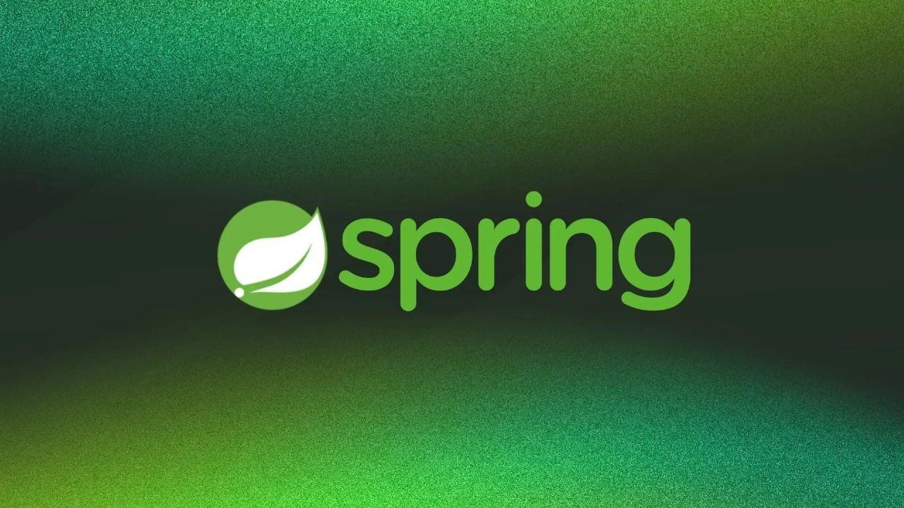

The Spring Framework

- https://spring.io <- the docs, which have always been pretty good
- We will be creating our Spring apps with https://start.spring.io/ NOT through Intellij.
- Spring itself is a loose term, it can mean many things in different contexts.
  - Without context, usually “Spring” refers to the overall Spring Framework.

What is Spring?

- The Spring Framework is an “ecosystem of tools”.
  - It’s a standalone open-source framework developed to support the development of enterprise scale Java applications.
    - Basically, it’ll make backend development easier.

- It provides layers of abstraction in our Java Projects, primarily through Dependency Injection (DI).
  - We’ll get into it below, but just know that DI is a huge part of what makes Spring apps so developer friendly and easy to create. We’re going to be operating on top of a ton of layers of Abstraction.

Quick Terminology Reference

- Beans (Spring Beans) - A Class registered with the Spring Container. A Class in the Spring Container is recognized by Spring Framework; thus, they can be injected into our Java application.
- Spring (IoC) Container - Creates Beans as objects, holds the beans, and injects them when they are called. Basically, this is where Beans are stored.
- Bean Wiring - Configuration that defines how beans are connected to each other. This is how we tell Spring where and how to inject our beans as dependencies.
  - We’ll talk about how to do this with an XML config file, a Java config Class, and annotations (we’ll typically use annotations after our first demo)
- Spring Module - Each of these is a part of the Spring Framework. These are required modules and optional modules that make up the framework.
- Spring Project - These are optional extensions of the Spring Framework. Basically, additional functionality is built upon the framework.

Inversion of Control (IoC)

- IoC is the act of taking control of some aspects of application away from the developer, and letting the Framework handle it instead. (The CONTROL of the application development is being INVERTED away from the programmer.)
  - In Spring’s case this is done through dependency injection. You can think of it as the Hollywood principle. You don’t call your dependencies yourself. Spring will call them for you.
    - Good article on DI and IoC
      - https://www.infoworld.com/article/2071914/excellent-explanation-of-dependency-injection--inversion-of-control-.html

Dependency Injection

- We’re not referring to Gradle dependencies, we’re referring to Classes that have other Classes as dependencies (like a Loan class that has a User field).
  - When we use Dependency Injection, we automatically provide the dependencies of an object when we create it.
  - If the Book Class has an Author field, the Author class is a dependency of the Book Class. The Author Class can be injected into the Book Class if it is a properly configured Spring Bean.

- Three Types we need to know about:
  - Constructor injection
    - We’ll usually use this.
  - Setter injection
    - Can be more flexible, lets us leave some dependencies unset.
  - Field injection (shouldn’t be used)
    - Breaks encapsulation – directly accesses fields instead of going through getters/setters
    - This also makes it difficult to write tests, because it can cause NullPointerExceptions if dependencies aren’t initialized.
      - You CAN use it, and it’s fine for quick mockups or low-stakes apps. But it’s typically not ideal for enterprise software.

Spring Beans

- Spring Beans are Java Objects managed by the Spring Container (read below)
  - With Spring beans, we can use dependency injection to instantiate objects with all their necessary dependencies.
    - Basically, Spring Beans are Java Classes that are managed by Spring that can be used for dependency injection.
- Beans can be defined in three ways:
  - XML Configuration via the <bean> tag in our applicationContext.xml
  - Configuration Java Class (@Configuration, @Bean, @Scope) (Won’t use)
  - ***Annotation Driven (stereotype annotations)
    - We can define beans with these 4 stereotype annotations:
    - @Component - General/generic annotation to make a Spring bean. Typically used for model classes.
    - @Repository - DAO Classes that you want to make a Spring bean
    - @Service - Service Classes that you want to make Spring Bean
    - @Controller - Controller Classes that you want to make a Spring Bean. This annotation has additional functionality if using Spring MVC.

- NOTE: Spring Framework will not treat any Class with these stereotype annotations differently from one another. They all do the same thing (Register a Class as a Bean). The difference in annotation names is purely for developer readability.
  - Some Spring Projects may add some slight functionality differences for these annotations - Like SpringMVC with @Controller.

Spring (IoC) Container

- “A Spring Container is an object that creates (instantiates) and holds your Spring Beans, then injects them wherever they’re being called in the application”
  - The container manages the lifecycle of your beans. (the Bean Lifecycle).

- We have two options for the Spring Container: BeanFactory or ApplicationContext
- BeanFactory:
  - Older
  - Lazily instantiates beans. (Bean objects aren’t created until they’re needed)
  - Requires a resource object configuration, generally called the beans.xml to be instantiated. It’s super verbose and ugly.
- ApplicationContext:
  - Newer, it’s actually built on top of BeanFactory – it's an abstraction!
  - Eagerly instantiates beans (When the application starts, all the beans are ready)
  - Provides support for annotations (No longer have to do everything in XML like we would have to if using BeanFactory)
  - The ApplicationContext can take XML configs directly for configuration as seen in the Main method/class in HelloSpring
    - E.g. ApplicationContext ac = new ClassPathXmlApplicationContext(applicationContext.xml);

Bean Wiring

- “Bean Wiring is how we connect our beans as dependencies of one another”.
  - Why do we connect beans as dependencies in the first place?
    - Maybe a Class depends on another Class for data (Employee needs a Role, Book needs an Author, etc.)
    - Sometimes you need access to other Classes to run their methods etc. (Controller class needs a Service class which needs a DAO class) We can use dependency injection to accomplish this!

- Types of Bean Wiring are the same as types of Dependency Injection (Read Above)
  - Constructor (We’ll usually use this)
  - Setter (Can be more flexible - partial dependencies)
    - This is actually the default in applicationContext.xml-based beans
  - Field (Bad, breaks encapsulation)

- Autowiring: “Automagically” determines the dependencies for you, and then provides them. There are two ways to use autowiring:
    - XML-Driven (Won’t use this after the first demo)
    - Annotation-Driven
      - @Autowired: put this annotation above a constructor, or setter, depending on what type of injection you want.
- So, you can manually code any of the types of dependency injections like we saw initially in HelloSpring or just use @Autowired, which is what the cool kids do.
  - Note: what does “automagically” actually mean? It’s called this because @Autowired will abstract away the dependency injection that it does for you. So to us, it looks automatic and magical.

Bean Scopes

- Bean Scope refers to how many instances of a Bean can be created and where they are used
- There are 6 bean scopes. 2 universal scopes, and 4 for specifically web-aware projects. (By web-aware I mean applications that can take HTTP requests)

- Universal:
  - Singleton (default): There will only ever be one instance of the Bean with the Bean’s class at one time.
    - Singleton is a Design Pattern that restricts objects to only one instance at a time. Can’t have mutliple instances of the same object.
  - Prototype: A new Bean (with potentially new values) is instantiated every time a Bean is called for.
- WebAware: (We will not cover/use them, but might be nice to know the names)
  - Request: One Bean of a class for each HTTP request that calls it.
  - Session: One Bean for each HTTP session.
  - Application: One per ServletContext
  - Websocket: One per Websocket

Spring Boot (Most Spring apps use Spring Boot)

- Spring Boot is a Spring Project (read below). A beautiful spring project. It’s kind of assumed that any Spring-based Java app is using Spring Boot.

- Spring Boot is a Spring Project used to create standalone Spring-based applications that you can just run. It prides itself on giving you a working app that you can run without any configurations on your end.
  - Spring Boot is opinionated: it makes decisions about how the application should be set up (the default configurations) so you can get it up and running with a couple clicks.
    - Spring Boot has the mindset of Convention over Configuration
      - This means that it’s designed to work with the standard industry conventions, and if you want to follow those conventions, it can abstract all of that setup away from you.

- Benefits and Features of Spring Boot

  - Embedded Tomcat Server - Spring Boot apps have built-in Apache Tomcat servers that we can easily configure. Javalin does something similar with a Jetty Server.
    - We can configure this server to fit our needs (like port number).
  - Configurations in general are easy in the application.properties file found in src/main/resources
    - No need for XML configuration like in our first demo! There’s an ApplicationContext Spring Container already built in.

  - Provides “starter” dependencies - This allows us to simply choose our dependencies from a list when we create our projects
    - Then, Spring Boot will construct our build.gradle for us
    - Some dependency examples include Actuator and Devtools:

  - Spring Boot Actuator: This dependency provides endpoints for us to monitor metrics and project information for our running applications.
    - /actuator/health: Shows application health information.
    - /actuator/info: Displays general application info.
    - /actuator/beans: Shows beans registered in the Spring IoC Container.

  - Spring Boot DevTools: This dependency provides additional tools for setting up a development environment easily and saving time during development.
    - For instance, it can automatically restart your server when you save changes, so you don’t have to manually restart it anymore.
      - (I won’t use this one cause it can cause Spring apps in corporate environments to get kind of janky. Maybe your team will have a working implementation)

- Running a Spring Boot application
  - For Spring Boot apps, you need to create a new project via https://start.spring.io/
  - To run a Spring Boot application, we simply need a @SpringBootApplication annotation above our main method Class.
  - In the main method, you will need: SpringApplication.run(<DriverClassName>.class, args);
- ***Remember, Spring Boot will generate all of this for us!!

Stuff I’ll get into after Project-based demos-------------------------

RestTemplate

- RestTemplate is a class that can be used in Java APIs to receive JSON information from an external Restful API (a different server). This is how we can send HTTP requests FROM our Java servers.
  - We instantiate a RestTemplate object to use its methods.
- RestTemplate is actually the older version of the library known as WebClient, which provides similar functionality.

- For the most part, we just use the ___ForObject() methods of RestTemplate
  - getForObject() for GET requests
  - postForObject() for POST requests
  - Etc.
    - Note: These methods take two parameters: the URL that the request is going to, and the type of object being requested/sent
  - We also have ____forEntity if we want to return the entire ResponseEntity for access to status code etc.

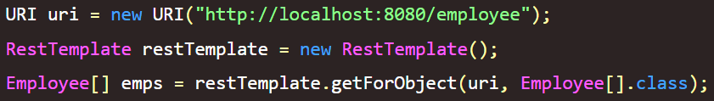
Basic example – sending a GET request to some API running on port 8080

Spring Environment Interface

- The Environment Interface provides a way to access and organize configuration through properties and profiles.
  - Not specific to Spring Boot, although Spring Boot builds on top of the concept.

- Properties: Configuration properties include database connection details, external service URLs, and other settings. These properties can be loaded from various sources, including property files, environment variables, and command-line arguments.
  - The application.properties file that we know and love will store these properties. Sample database config:
  - 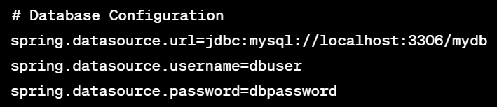

  - We can even access these properties within our logic! 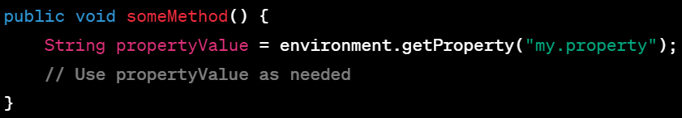

- Profiles: Spring applications can define different profiles, such as "development," "testing," and "production." Profiles let you define distinct configurations that can be applied wherever they are needed.
  - I think of these as reusable configuration templates that you can attach to any environment that requires those configurations.
  - 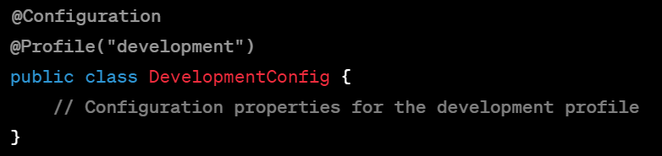

- How do we apply Spring profiles?
  - You can create different application-{profile}.properties files:
    - application-dev.properties
    - application-test.properties
    - application-prod.properties
      - (These names are exact syntax btw)
- Then we simply set which profile we’re in via the class (seen about) or through the main application.properties like this:
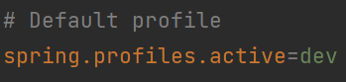

Bean Lifecycle

- Why oh why do we need to learn this mostly under the hood process? Spring stack traces can be very vague and misleading. If you know the bean lifecycle, you’ll have a better idea of where to look for problems.
  - It’s a process full of methods that take place when a Bean is created and destroyed.
  - NOTE: The revpro notes have a good (slightly different) explanation of this. At least, understand this image:
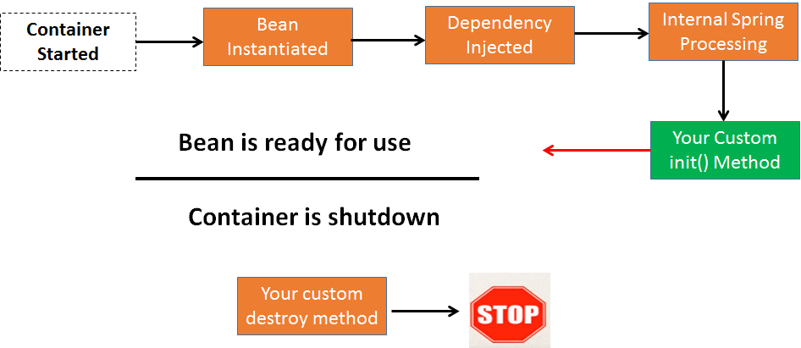

- Implementation – These are all the steps listed in “Internal Spring Processing” and you probably don’t need to go this deep:
  - Setup (If they’re italicized you definitely don’t need to know them)
    - 0 - Bean is called/instantiated
    - 1 - BeanNameAware’s setBeanName();
    - 2 - BeanClassLoaderAware’s setBeanClassLoader();
    - 3 - BeanFactoryAware’s setBeanFactory();
    - 4 - ResourceLoaderAware's setResourceLoader (only applicable when running in an application context)
    - 5 - ApplicationEventPublisherAware's setApplicationEventPublisher (only applicable when running in an application context)
    - 6 - MessageSourceAware's setMessageSource (only applicable when running in an application context)
    - 7 - ApplicationContextAware's setApplicationContext (only applicable when running in an application context)
    - 8 - ServletContextAware's setServletContext (only applicable when running in a web application context)
    - 9 - BeanPostProcessor’s postProcessBeforeInitialization()
    - 10 - InitializingBean’s afterPropertiesSet();
    - 11 - Your own custom initialization method (defined with @PostInit)
    - 12 - BeanPostProcessor’s postProcessAfterInitialization();
  - Teardown
    - 1 - DisposableBean’s destroy()
    - 2 - Your custom destroy method (defined with @PreDestroy)
    - 3 - Garbage Collection eventually

  - Setup starts when a Bean is called. Teardown is POSSIBLE once the bean is eligible for Garbage Collection – when there are no more live references to it.

Spring Modules

- Spring Modules are main pieces of the Spring Framework. There are required modules needed for Spring to work as intended, and optional modules not needed but often used.

- Required Modules
  - Spring Core: This module contains the core functionality of Spring. Contains the BeanFactory interface which is one of the two IoC containers you can use.
  - Spring Context: Provides the ApplicationContext interface, which is the IoC container we use.
  - Spring Bean: Contains Bean configuration and functionality
- Optional Modules
  - Spring Web/MVC: Provides functionality for Spring to use Javalin-like functionality (gathering HTTP requests and sending back responses) with annotations in the Controller layer.
  - SpringAOP: Aspect Oriented Programming - Handles “cross cutting concerns” such as logging. We won’t cover this, but it might be cool to investigate.
  - There are plenty more that we will not need to cover, feel free to look into them.

Spring Projects

- Spring Projects are built on top of Spring modules and provide solutions to issues faced by industry level applications. So they aren’t “main” pieces of the Spring framework, but think of them as add-ons that make our lives easier as developers.
- There are a large variety of Spring projects. You can find them here:
  - http://spring.io/projects
  - Spring Projects are all open source so you can look directly at the source code for them:
    - http://github.com/spring-projects
- Spring Framework is considered the foundational Spring Project!! It’s built on top of the Spring Core Module.
  - Spring Boot is considered a Spring Project too
- SpringORM/SpringData: Two modules that handle the application’s ORM (Object Relational Mapping) and the database connection. We’ll only be using SpringData.
  - A lot of the members we’ll use in Spring Data are provided/supported by Spring ORM
- Spring Security: We’ll see this around P3 season. Modern way to secure a spring boot application, and easy integration with JWTs for login validation.

Project Lombok

- Project Lombok is a framework designed to remove the need to write repetitive boilerplate code for our Classes (typically the models).
  - Lombok lets us use annotations to inject boilerplate code into your Java classes, instead of writing them out in code. The code is inserted for us at compile time.

- Annotations:
  - @Getter
  - @Setter
  - @NoArgsConstructor
  - @AllArgsConstructor
  - @ToString
  - @EqualsAndHashCode
  - @Data
  - @RequiredArgsConstructor – automated dependency injection
  - and others...
- Lombok installation:
  - For your IDE to work well with Lombok, it must be installed in the IDE. Otherwise, it will not be aware of the methods that Lombok is providing.
    - In Intellij: File -> Settings -> Lombok
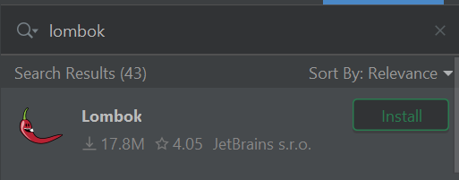

  - You will also need the gradle dependency for lombok before your app can use it.
- Why might Lombok NOT be a good choice?
  - If you’re working on a personal project that only you or a small team will use, it’s probably fine.
    - But it’s good practice to see your boilerplate while you’re learning this stuff. It can also be good to have your boilerplate written explicitly when you’re debugging and error handling.
  - Another problem arises when many people (even strangers) intend to clone and develop the application. By implementing Lombok, you force other developers working with your project to use it too.

Example of fully Lombok-ed Model Class
